South Africa

## Political Stability Estimate Data

The data set shows the political stability estimate of the country each year.

## # A tibble: 19 x 5  
## country iso3c date stability stabilityCategory4   
## <chr> <chr> <dbl> <dbl> <chr>   
## 1 South Africa ZAF 1996 -0.377 moderately unstable  
## 2 South Africa ZAF 1998 -0.543 moderately unstable  
## 3 South Africa ZAF 2000 -0.225 moderately unstable  
## 4 South Africa ZAF 2002 -0.254 moderately unstable  
## 5 South Africa ZAF 2003 -0.312 moderately unstable  
## 6 South Africa ZAF 2004 -0.131 moderately unstable  
## 7 South Africa ZAF 2005 -0.163 moderately unstable  
## 8 South Africa ZAF 2006 0.0482 moderately stable   
## 9 South Africa ZAF 2007 0.216 moderately stable   
## 10 South Africa ZAF 2008 0.0497 moderately stable   
## 11 South Africa ZAF 2009 -0.113 moderately unstable  
## 12 South Africa ZAF 2010 -0.0294 moderately unstable  
## 13 South Africa ZAF 2011 0.0240 moderately stable   
## 14 South Africa ZAF 2012 -0.0254 moderately unstable  
## 15 South Africa ZAF 2013 -0.0463 moderately unstable  
## 16 South Africa ZAF 2014 -0.146 moderately unstable  
## 17 South Africa ZAF 2015 -0.213 moderately unstable  
## 18 South Africa ZAF 2016 -0.142 moderately unstable  
## 19 South Africa ZAF 2017 -0.267 moderately unstable

## Political Stability Estimate Plot

The plot shows the trends of stabilization and destabilization for the each country.

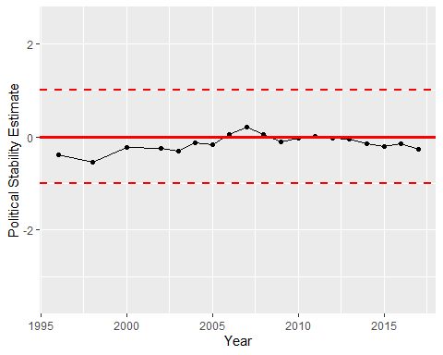

Political Stability Trend